Created by: David Rubio G.
Blog: https://soceame.wordpress.com/
GitHub: https://github.com/DRubioG
Last modification date: 11/03/25

In this post I will explain how to connect an IP block in Libero (within the limits allowed by Microchip tools).
To connect an IP block the first thing you have to know is the type of interface to use. In a previous post I already explained how to create an interface.
https://soceame.wordpress.com/2025/03/11/how-to-create-a-bif-interface-in-libero/
In our case we will use an IP block called CorePWM included in Libero.
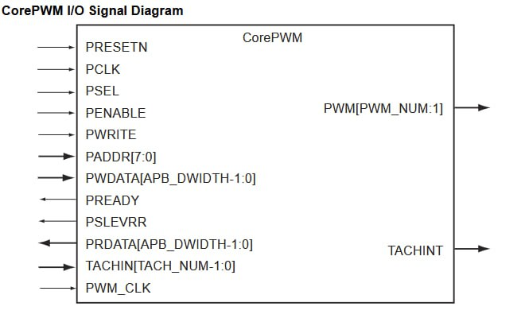
This block has an APB type interface so to be able to connect it to a SmartFusion2 or a PolarFire SoC a CoreAPB3 type interface is needed. This interface allows communication through memory addresses with the IP block.
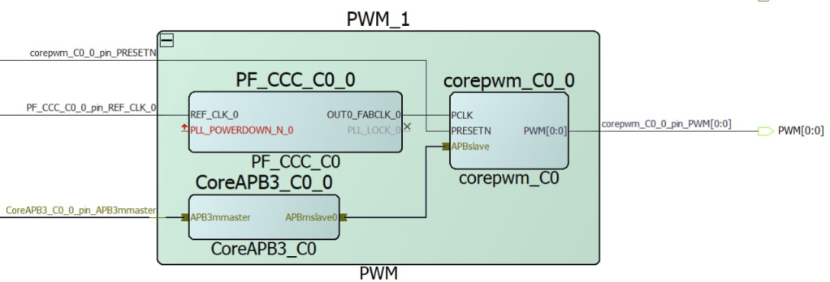
So, if we look at the memory address of the IP block, we see that it has the memory address 0x40000000.
https://soceame.wordpress.com/2025/03/11/how-to-access-ip-block-memory-addresses-in-libero/
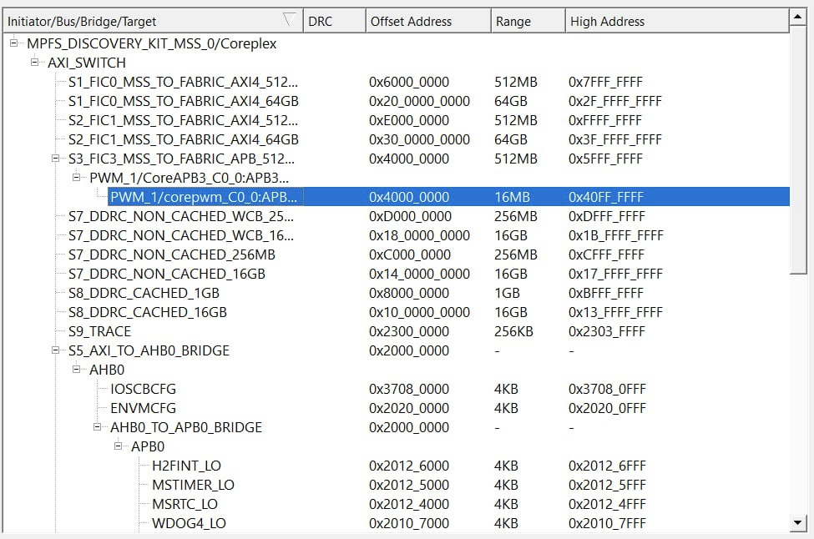
The IP block also requires a clock to run, which can be the one from the MSS or another one. And a reset, which can be the one generated by the MSS.
The structure of the project would be something like this.
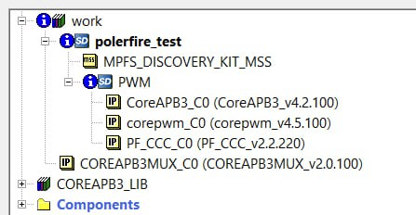
So now all we have to do is connect the CoreAPB to the MSS APB FIC interface.
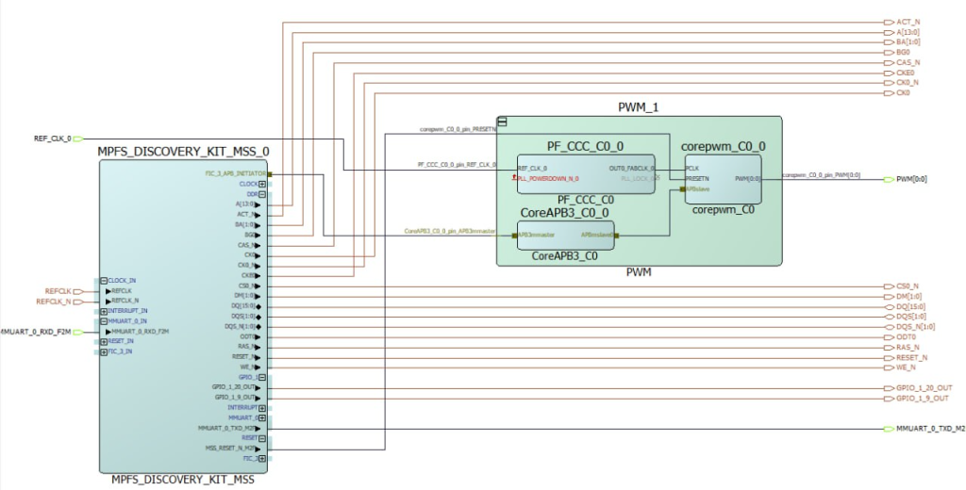
Now with the SoC memory address, all we need to do is go to the SoftConsole to implement the IP block configuration.
To do this, we use the internal memory table provided by Microchip.
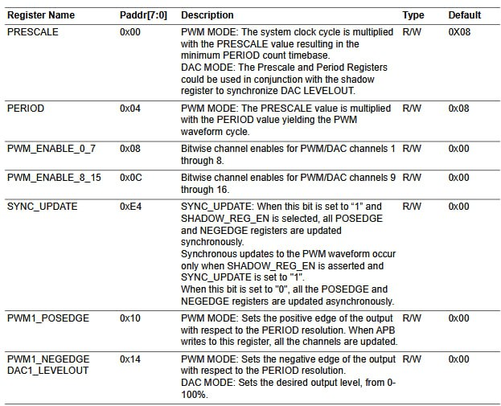
It also provides a mini example that will be used for the SoC.
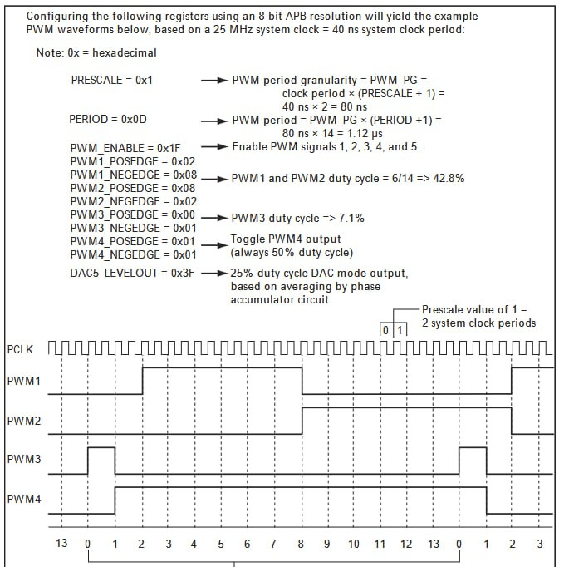
With this example, we develop the application that makes the PWM work.
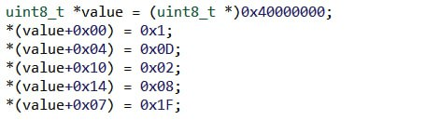
NOTE: Because Libero SoCs are poorly documented and the examples they provide are too complex, the previous project does not work because the processor crashes. Even so, the workflow is well defined to configure Microchip SoCs.

